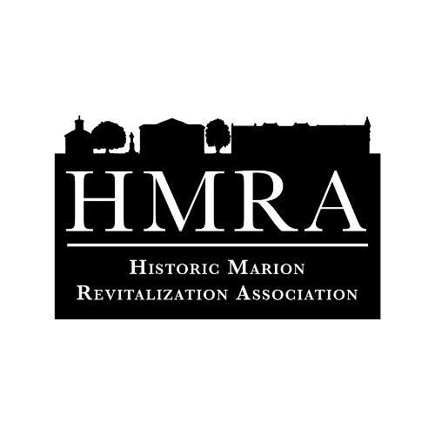
Historic Marion Revitalization Association
Paint Your (P)art
103 E. Dozier St
Marion, SC 29571

HMRA is happy to announce the 4th annual Paint Your (P)art art installation contest. This community contest has been created to give our county a creative outlet in a public display, as well as unite the people of Marion with a common interest. Please read the requirements and restrictions below before entering the contest. Anyone not adhering to the following guidelines risk disqualification from the contest, based on the decision of the Paint Your (P)art Art Committee.
Overview: Paint Your (P)art art installation contest will begin on February 13, 2024. Entries will be accepted online or in the office. All applications and draft drawings must be submitted by March 5th at 5pm. Rough draft drawings of the planned art shall be sketched in color in an 8” x 8” square. A 5 person Paint Your (P)art Committee consisting of the HMRA Executive Director, one HMRA board member, and three community members will review all completed applications and choose 10 finalists from submitted applications. Finalists will be notified by March 19th if they have been chosen and will need to pick up their art board by March 26th. Finalists are responsible for the materials needed to produce their art (paint, utensils, materials, etc). All final art pieces are to be turned into the HMRA office no later than April 25th.
Finalists give the right to HMRA to waterproof each piece of art, as well as affix it to the outdoor structure. Voting for art will take place online, as well as in participating Historic Downtown businesses. People are invited to vote once at each participating business, as well as online. The piece of art with the most votes will win. In the case of a tie, first place and second place prizes will be split equally amongst winners. Artists agree to have their art on display as long as HMRA expects, yet not to exceed one year. At the end of the year, the art will be available to the artist to pick up. Any art not picked up by June 2025 will become the property of HMRA.
Regulations:
1. Contestants are limited to those who either live or work within Marion County. Proof of residency or work may be requested.
2. Contestants must be age 15 or older.
3. Individuals may enter only one time per year.
4. Any relative of judges are unable to enter the contest.
5. All work must be original to the person applying to the contest.
Prizes:
1. Prizes will be dispersed the week after voting is concluded.
2. First place - $400; Second place - $200; Student Division - $200
3. At least one prize will be awarded to a student living or working withing Marion County. The student must be enrolled in school during the 2024-2025 school year and will be voted on by the Paint Your (P)art Committee. It is possible a student can win the Student Division and the popular vote.
4. Anyone found in violation of the regulations or overview is disqualified from the contest and awards. *Dates subject to change. Visit www.theswampfox.org for changes/updates.

